Noun Attribute

✅ What is Noun Attribute?
# Source: AI Source: Provided by: [Data Path: Persons Table -> ID Column: 1, Name_En Column: Motasem Essam] -> From: [Chatgpt (GPT‑5 Mini)] on [8/7/2025]
A Noun Attribute is a noun that functions like an adjective to modify another noun. It usually appears directly before the head noun and provides specific or classifying information.
It is also called an attributive noun or noun modifier.

🔹 Key Features:
# Source: AI Source: Provided by: [Data Path: Persons Table -> ID Column: 1, Name_En Column: Motasem Essam] -> From: [Chatgpt (GPT‑5 Mini)] on [8/7/2025]
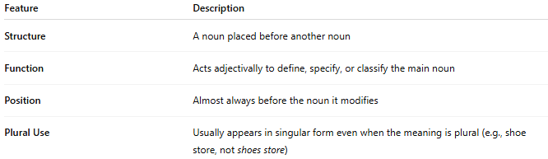
Feature | Description
Structure | A noun placed before another noun
Function | Acts adjectivally to define, specify, or classify the main noun
Position | Almost always before the noun it modifies
Plural Use | Usually appears in singular form even when the meaning is plural (e.g., shoe store, not shoes store)

🔹 Examples:
# Source: AI Source: Provided by: [Data Path: Persons Table -> ID Column: 1, Name_En Column: Motasem Essam] -> From: [Chatgpt (GPT‑5 Mini)] on [8/7/2025]
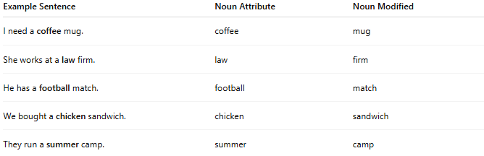
Example Sentence | Noun Attribute | Noun Modified
I need a coffee mug. | coffee | mug
She works at a law firm. | law | firm
He has a football match. | football | match
We bought a chicken sandwich. | chicken | sandwich
They run a summer camp. | summer | camp

🔹 Common Noun Attribute Types:
# Source: AI Source: Provided by: [Data Path: Persons Table -> ID Column: 1, Name_En Column: Motasem Essam] -> From: [Chatgpt (GPT‑5 Mini)] on [8/7/2025]
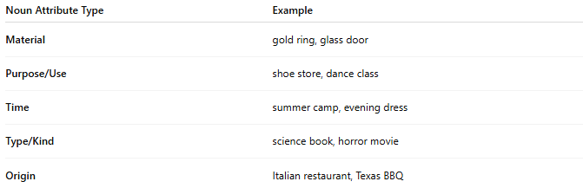
Noun Attribute Type | Example
Material | gold ring, glass door
Purpose/Use | shoe store, dance class
Time | summer camp, evening dress
Type/Kind | science book, horror movie
Origin | Italian restaurant, Texas BBQ

